Currently you will see the below as there is an active PR, that is needed your action to put in the comments. Details below.

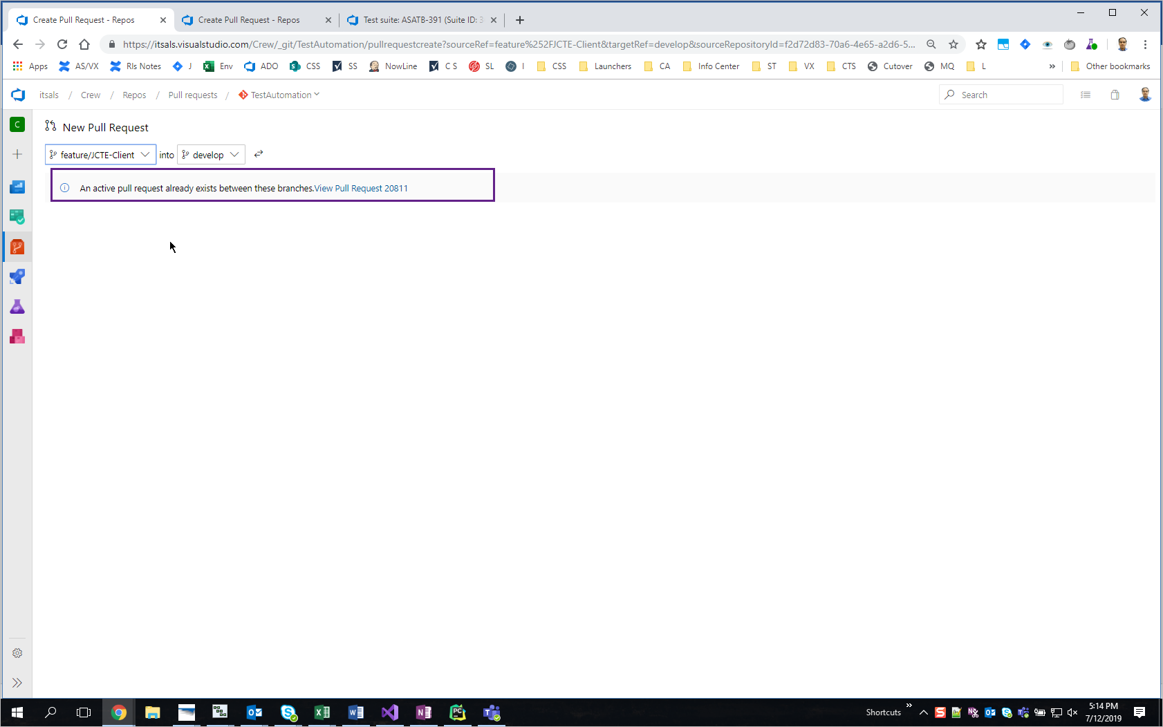

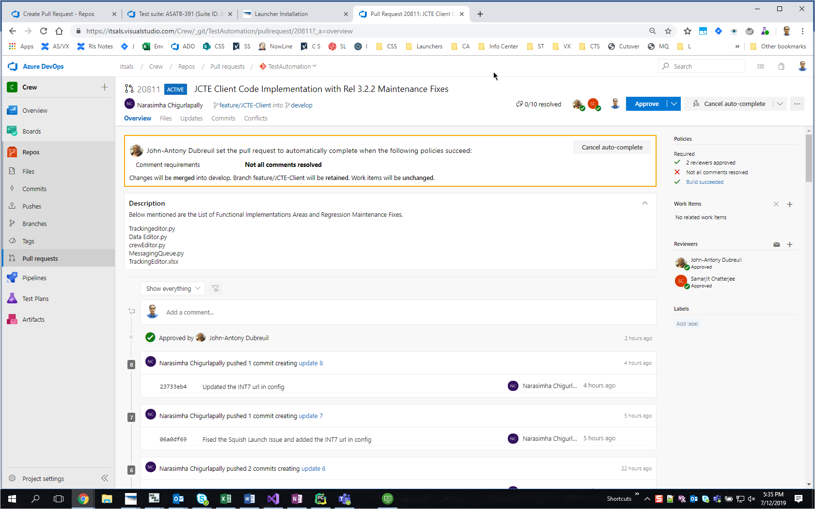

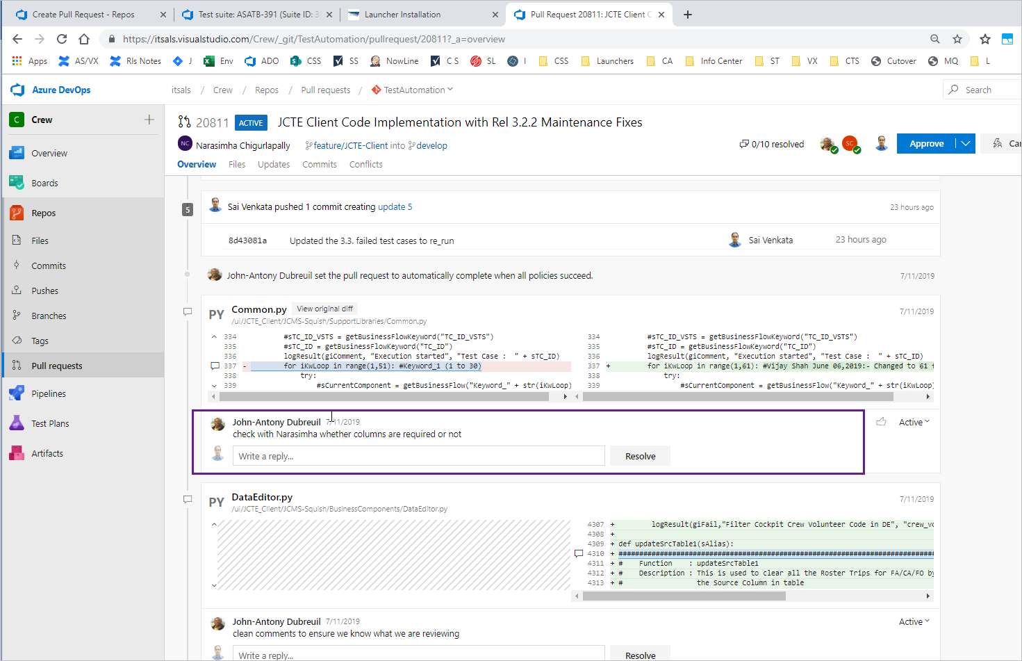

Just add a comment that: for a test case on the user roles had the key words, hence increased.

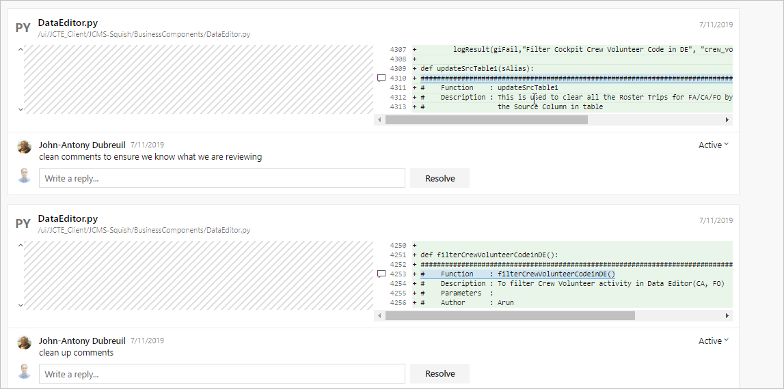

Please add comments stating that, first update the code stating that : # Line # <x> to <y> is commented , so that will be used as and when needed. Please add a comment in the write a reply text box.

Do the same accordingly and pls re-submit today morning it self. JA works in the night, so he can approve.